# Internal Table

## Using Structure in SE38

TYPES: BEGIN OF lty_data,(local type – naming conventions)

ONO TYPE ZDEONO_28,

PM TYPE ZDEPM_28

END OF lty_data.

Declaring internal table

DATA: lt_data **TYPE TABLE OF** lty_data.

## Using Structure from SE11

When we declare it from SE11 it is reusable

Figure 1 Creating Structure from SE11

Figure 2 Choose Structure

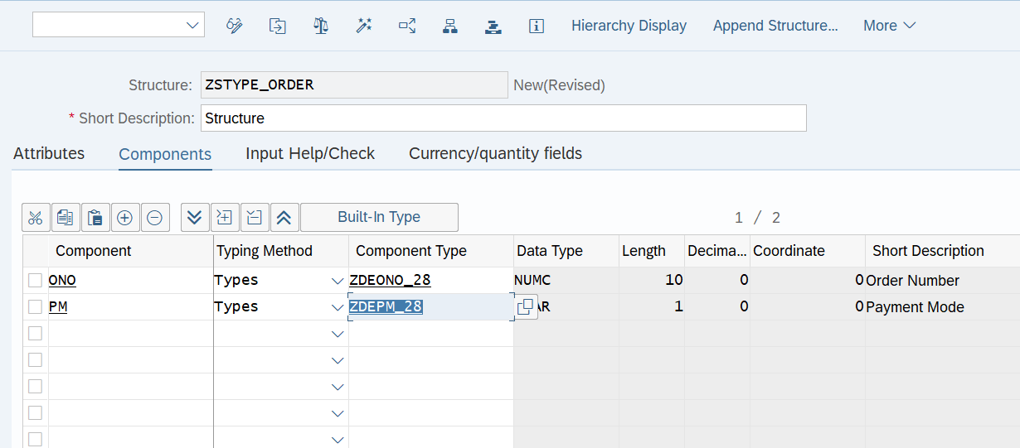

Figure 3 Creating Structure

Figure 4 Save it as Local Object

Check the Syntax and Activate it

## Using Table Type from SE38

TYPES: ltty_data TYPE TABLE OF lty_data.

Where lty_data is a Structure

Data: lt_data3 TYPE ltty_data.

We are creating an internal table but without using TYPE TABLE OF keyword

## Using Table Type from SE11

Figure 5 Creating Table Type

Figure 6 Selecting Table Type

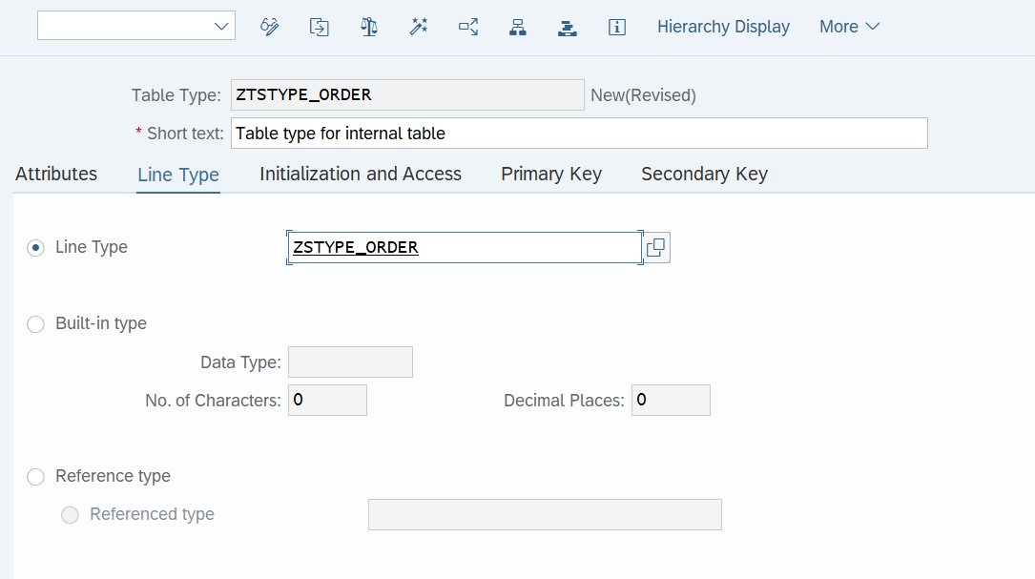

Structure Type

Figure 7 Creating Table Type

# Types of Internal Table

## Standard Internal Table

* They are the default internal table.
* They are the index based internal tables.
* Record can be inserted or appended.
* Data is not sorted by default; we can use SORT statement to sort the internal table.
* We read a record using KEY or Index.
* Either linear search or binary search is used to search a record.
* Response time depends upon the number of entries in the internal table.

TYPES: BEGIN OF lt_struc,

Ono TYPE zdeono_28,

Pm TYPE zdepm_28,

END OF it_struc.

DATA: it_data TYPE TABLE OF It_stuc,

It_data1 TYPE STANDARD TABLE OF It_struc.

If we don’t mention the type it will consider the internal table as standard internal table by default.

* Append Inserts the record at the last of the internal table where as insert.
* Inserts the record at anywhere in the internal table.

## Sorted Internal Table

## Hashed Internal Table

# Work Area

We can declare work only using the structure we cannot declare using the table.

DATA: lwa_data **TYPE** lty_data.

# Internal Table with header line

* In the case of an internal table with a header line, there is an implicit(internal) work area.

(Implicit header table: - (Internal work area) We don’t need to declare different names for internal table and work area sap that means lt_data(internal table) It_data(work area) but it is absolute now)

* The name of the work area is the same as that of the internal table.
* To clearly identify the internal table use brackets after the internal table name(<itab>[])
* Clear <itab>[] – Clear the contents of the internal table

**Note: - In the case of an internal table with a header line, Clear <itab> clears the work area, not the internal table. If you want to clear the internal table use brackets after the internal table name.**

# Internal Table without header line (Preferred)

* We can avoid the confusion of internal table with header line by using the concept of the internal table without a header line.
* In the case of an Internal table without a header line, there is an explicit(external) work area.
* We declare an explicit work area.
* The name of the Internal table is different from that of the work area.
* Clear <itab> - Clears the content of the Internal table.